**Project Operational Research**

INFO AN 3.  
By Ziad Hammada.

***EXERCICE:***Make a program that solves a linear programming problem using the graphical method or the simplex algorithm.  
  
**PROBLEM SLOVING:**using the graphical method.  
RUN VSCODE + PYTHON FILE.  
PYTHON CODE :at the PDF file attached to the email.  
the function used in this exemple is Z=3x+2y  
Subject to the following constraints:

2x+y ≤10  
4x-5y ≥-8

X ≥0

y ≥0

**My python png code:**

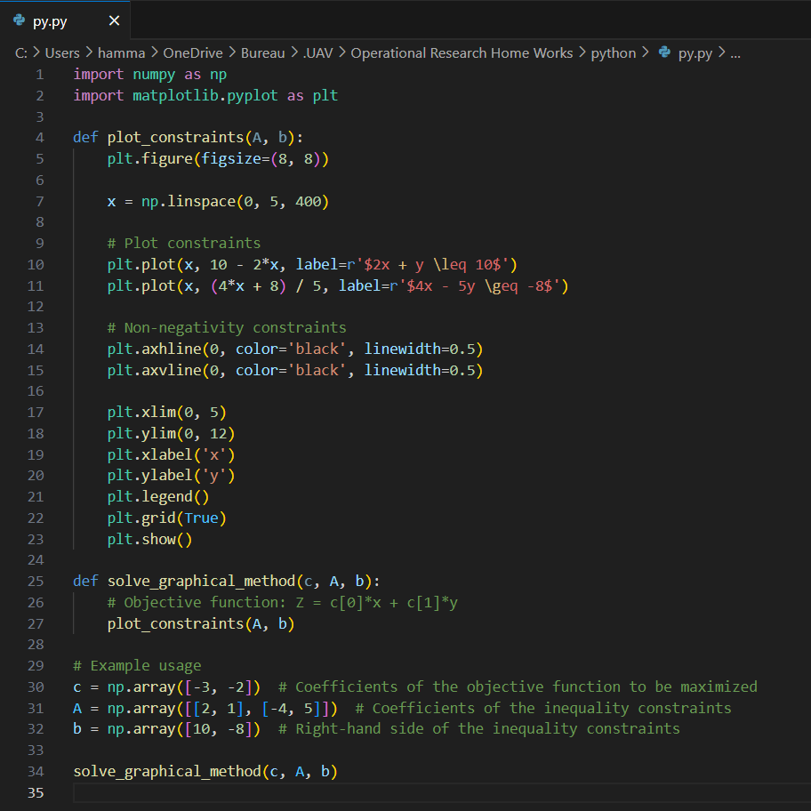

**THE GRAPH**  
